COMSATS UNIVERSITY ISLAMABAD

L AHORE-CAMPUS

**Power Electronics**

**Course Code: EEE-338**

**CEP Project Report**

**Project Title: Fast Switching Automatic Voltage Stabilizer**

**Submitted By:**

Muhammad Abdullah (FA19-BEE-151)

Osama Riasat (FA19-BEE-016)

**Submitted To:** Engr. Ms. Madiha Sultan

Date: December 27, 2021

**Declaration**

*“No portion of the work referred to in the dissertation has been submitted in support of an application for another degree or qualification of this or any other university/institute or other institution of learning”.*

|  |
| --- |
| **MEMBERS’ SIGNATURES** |
|  |
|  |

Acknowledgements:

*“In the name of God, the most kind and most merciful”*

We would also like to thank Ms. Madiha Sultan for his guidance and encouraging me to work hard and smart. We have found him very helpful while discussing the optimization issues in this dissertation work. His critical comments on my work have certainly made me think of new ideas and techniques in the fields of optimization and software simulation.

We are grateful to the God Almighty who provides all the resources of every kind to us, so that we make their proper use for the benefit of mankind. May He keep providing us with all the resources, and the guidance to keep helping the humanity.

*ABSTRACT*

*Most of everyday devices need an AC supply to work on, that make our life comfortable and luxurious. For the optimum functionality of the device, it is necessary that the supply should be regulated in the statutory limits of voltage variation ±6 % and frequency variation of ±1 % of rated value at consumer terminal. But in our country we are facing deficiency in power generation end to meet supply and demand that actually cause the violation of these limits in distribution voltages at consumer end. There could be many other reasons by which there is a fluctuation in the supply voltage. This change in the supply voltage may cause the device to damage or make it work in an undesired way. Hence the best alternative is to regulate the supply voltage using a voltage stabilizer.*

*Mostly stabilization of voltage is done by relay based stabilizers or AVRs using servo mechanism. In both techniques due to the mechanical parts involved in them they are bulky, noisy and have wear and tear with the passage of time. Switching speed of voltage correction may not be fast enough for electronic loads which in turn can damage them. That is to device an automatic voltage stabilizer for a room size (max 200Watt) refrigerator using thyristor (SCRs), that will work for input range of 170 to 270V and stabilize the output at rated voltage and frequency. This system also provide short circuit protection and is smaller in size, no noise or wear issues in it. It provide better response time with inherent fast switching speed of SCRs of almost 20 KHz. A display is provided for input voltage, output voltage and fault type (if occur) information*

Table of Contents

Acknowledgements 3

ABSTRACT 4

1 INTRODUCTION 9

1.1 OBJECTIVES 9

1.2 CHAPTERS OVERVIEW 10

2 LITERATURE REVIEW 11

2.1 BACKGROUND 11

2.1.1 SERVO BASED 11

2.1.2 RELAY BASED 12

2.1.3 MANUAL VOLTAGE STABILIZER 13

2.2 RELATED WORK AND MARKET SURVEY 14

3. REQUIREMENTS SPECIFICATION 15

3.1. DESIGN REQUIREMENTS 16

3.2. DELIVERABLES 17

3.3. SAFETY AND SECURITY 17

3.4. AUTOMATION 18

3.5. FUNCTIONALITY 18

4. PROJET DESIGN 19

4.1. METHODOLOGY 19

4.1.1 AUXILARY POWER SUPPLY 20

4.1.2. INPUT AND OUTPUT VOLTAGE AND CURRENT MEASUREMENT 21

4.1.2 CONTROLLED SCR TRIGERRING 23

4.2 DESIGN DESCRIPTION 24

4.2.1. PIC MICROCONTROLLER 24

4.2.2 OPTOCOUPLER 26

4.2.3 TRIACS 28

5. IMPLEMENTATION 29

5.1 DEVELOPMENT STAGES 29

5.1.1 TRANSFORMER SPECIFICATIONS 29

5.1.2 INPUT VOLTAGE MASUREMENT 31

5.1.3 OUTPUT VOLTAGE MEASUREMENT 32

5.1.4 INPUT CURRENT MEASUREMENT 32

5.1.5 OUTPUT CURRENT MEASUREMENT 33

5.1.6 CONTROLLED SCR TRIGERRING 33

5.1.7 PCB IMPLEMENTATION 34

5.1.8 SYSTEM INTEGRATION 37

6 FUNCTION TESTING 38

6.1 TESTING OF COMPONENTS 39

6.1.1 TESTING OF TRIACS 39

6.1.2 TESTING OF OPTOCOUPLERS 39

6.1.3 SYSTEM TESTING 40

6.2 RESULTS 40

7 CONCLUSION AND FUTURE WORK 42

REFERENCES 44

Appendix A: HDL or C Source Code 45

Appendix B: Hardware Schematics 61

Appendix C: List of Components 66

Tables of Figures

Figure 1 Servo Type Stabilizer Circuit Diagram 11

Figure 2 Relay Type Stabilizer Circuit Diagram 12

Figure 3 Basic Manual Voltage Stabilizer with up-down switch 13

Figure 4 Block Diagram 20

Figure 5 Bridge Rectifier Circuit 21

Figure 6 Construction Schematic and Current transformer 23

Figure 7 Trigerring Circuit 23

Figure 8 PIC Pin Configuration 25

Figure 9 Optocouplers 28

Figure 10 Triac schematic 29

Figure 11 Eddy Current, magnetizing current and their relationship 31

Figure 12 Optocouplers Driving Triacs 34

Figure 13 Proteus simulation of SCR stages 34

Figure 14 PCB for SCR circuit 36

Figure 15 PCB for micro controller 36

Figure 16 PCB for auxiliary power supply 37

Figure 17 Proteus simulation of integrated circuit 38

Table of Tables

Table 2.1 Different voltage stabilizer comparison………………………………………… 13

Table 2.2.1 Technical parameters of D&C 10KVA voltage stabilizer……………………..14

Table 2.2.2 Technical parameters of solid 3KVA servomotor type single phase ac AVR…14

Table 2.2.3 Technical parameters of CKEN 15KVA voltage stabilizer……………………14

Table 3.1 Design requirements of system…………………………………………………..15

Table 3.2 Deliverables of project…………………………………………………………...16

Table 3.3 Safety and security of project…………………………………………………….16

Table 3.4 Automation of project…………………………………………………………….17

Table 3.5 Functionality and major components of project………………………………….17

Table 5.1.1.1 Number of turns of transformer………………………………………………29

Table 5.1.1.2 Wire gauge of transformer……………………………………………………29

Table 5.1.8 Voltage appearing on taps and taps selection criteria…………………………..37

Table 6.2 Results of testing………………………………………………………………….40

# 1. INTRODUCTION

In most of the commercial voltage regulation, automatic voltage regulators are used for the purpose. In typical AVRs, switching is done by electromagnetic relays, or servomotors which automatically select taps in the transformer to get the required voltage to boost (add) or buck (subtract) the input voltage [1]. Relay tap changers have the problems such as power lost at the moment during relay change over, unstable output and the relay contacts get damaged d. Servo motor type has the disadvantages that they have comparatively low life of the contact points of the relays also mechanical driven components like brushes and contractors require regular maintenance and/or replacement [2]. Voltage stabilizers that use solid state electronic devices can overcome most of the above mentioned problems as they do not have any moving part and the output voltage will be smooth.

The main application of a tap-changer regulator is to regulate the amplitude of the output voltage. The major function of the controller in the tap-changer stabilizing system is to minimize the fluctuation of voltage amplitude with respect to the reference voltage of 220 volts.

Microcontrollers are used for controlling purpose in wide range of applications [3]. Implementation of microcontroller and SCR based automatic voltage stabilizer will provide better response time with inherent fast witching speed of SCRs and a display will be provided for input voltage, output voltage, frequency and fault type (if occur) information.[4]

SCR also called thyristor controller, employing novel technology that is designed to provide a price effective and suitable solution for power requiring applications, current or voltage regulation with a smoother process control. When simple voltage or current regulation is required often controlling phase angle is the most cost effective solution. An SCR operates at line frequency and turned off by natural commutation [5]. SCRs are switched on by using a gate. Thyristor starts conduction in a forward direction when a trigger current pulse is passed from gate to cathode. It cannot force its current back to zero by its gate signal. Thyristor automatically switch off again when they conducted current reaches zero. [6]

In project supply load with a constant voltage of 220 volts AC using a transformer with multiple taps which allows stepping the voltage [7]. Connected pairs of SCR stages and load are connected parallel to these SCR stages. When any fluctuation in the supply line occurs then the controller will decide that which SCR stage will turn on to maintain a constant voltage of 220 Volts

## 1.1 OBJECTIVES

We have set the following goals as our objectives to lead us into the starting of our project

towards its completion.

* To finalize our components and collecting the data about them in order to acquire them.
* To select a transformer with multi taps on secondary side.



* To design appropriate SCR stages for stabilizing the voltage on secondary side.
* To develop a suitable method for connecting these SCR packages with transformer and controller in order to trigger them on and off.
* To design a system for measuring input voltage and current.
* To choose a suitable controller and write a scenario based code for the hardware.
* To select appropriate wire gauges for connecting all the components of our overall design
* Testing and debugging of computer code and hardware.

## 1.2 CHAPTERS OVERVIEW

The research includes implementation of microcontroller and SCR based automatic voltage stabilizer which provide better response time with inherent fast switching speed of SCRs.

Chapter 2 covers the background material and literature reviewed to understand the intricacies of automatic voltage regulator. It also consists of reviews of the project that have been completed lately of the same field.

Chapter 3 covers the requirement specifications of the project. It explains about the specifications of the project.

Chapter 4 covers the methodology of the project. It consists of the information related to the working of the whole system. The architecture overview and the design of the project will also be a part of this chapter.

Chapter 5 consists of the implementation of the project. It will cover the stages of process in making this project. It will also cover the information and significance of the main components that are involved in the making of this project.

Chapter 6 covers the evaluation of the project. In this chapter the testing of the function of the project will be shown with clear results

Chapter 7 covers the conclusion and the betterment that can be brought in this project in future

# 2. LITERATURE REVIEW

## 2.1 BACKGROUND

The automatic voltage regulator is a device designed to stabilize voltage automatically, which means to maintain a constant voltage level. Automatic voltage regulators are of many types. Now-a-days, major previously used voltage regulation systems have been discarded due to their major drawbacks over newly electronic based systems. The major disadvantages of a mechanical tap changer power transformer with load are that it produces arcing, and it requires regular maintenance, it has more serving costs and has slow response times. Previously used major types of voltage regulations are

TYPES

* SERVO BASED
* RELAY BASED
* MANUAL BASED

### 2.1.1 SERVO BASED

Servo motor based controlled automatic voltage regulator constitute of following parts.

1. Buck/Boost Transformer: a transformer is connected at the input and at the output of terminals of load that is to buck or boost the voltages. One terminal of this transformer is connected to the motor shaft whereas the other is connected with the auto transformer
2. Auto transformer: It is a coil of wire shaped like a doughnut, connected between positive and negative of input power supply.

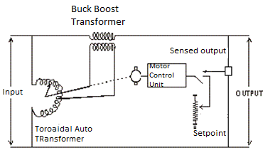

Figure 1 Servo Type Stabilizer Circuit Diagram

1. Motor: One terminal of Buck Boost transformer is connected to the shaft of rotating motor with help of carbon brushes mechanism. The motor moves and the shaft rotates to increase or decrease the voltages on the taps of transformer. Motor is fitted on the top of auto transformer center and is generally ac synchronous or Dc servo motor.
2. Motor Driver: motor driver is the mechanism used to control the movement and mechanism of motor. It consists of printed board consisting of solid state circuit made up of capacitors, resistances, transistor Amplifiers, microprocessors and integrated chips.
3. Control Circuitry Power supply: It needs constant incoming DC power supply to the printed board. It converts Ac to Dc and it has step down transformer and bridge rectifier to convert the supply

**WORKING**

Voltages that are applied at input of automatic voltage regulator are connected to another feedback circuit that has microcontroller or chip. This microcontroller receives the input voltages continuously with the help of feedback. Whenever a high or low voltage appears at the terminal of transformer the microcontroller moves the shaft of moor accordingly to maintain the desired level of voltages.

**DISADVANTAGES**

Disadvantages of servo type are as follow:

* It has moving components that require a lot of regular maintenance.
* Low response time and low response speed as compared to static based voltage stabilizer.

### 2.1.2 RELAY BASED

Relay type auto voltage regulator has relays to regulate the voltages. it is also called solid state voltage stabilizer as it has no moving parts in it and it doesn’t require much maintenance as compared to servo type voltage stabilizer. Advantage of Relay type stabilizer is that it has less weight and is cost effective.

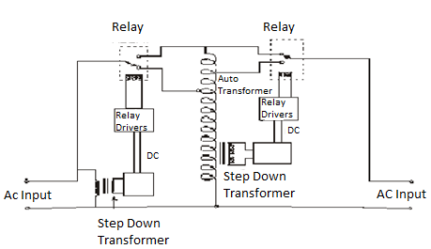

Figure 2 Relay Type Stabilizer Circuit Diagram

**WORKING**

A relay type AVR does not require any manual interference to on the stabilizer. It has rely switches to change the connection of auto transformer so therefore the voltage correction is fully automatic on load

The major parts of a basic relay type automatic voltage stabilizer are  
1. Autotransformer or transformer with taps  
2. Relays or relay switches  
3. Relay driving circuit  
4. Control circuit consisting of microcontroller  
5. Auxiliary power supply  
6. Accessories

The relay type automatic voltage regulator mechanism is as same as that of a manual voltage stabilizer. Relays switches are connected to the transformer to take input as well output. Relay circuits are controlled by integrated chips, microcontroller or transistors. Step down transformer that is connected to input usually takes 18 volt to 12 volt. These voltages are rectified to dc voltages and are supplied as a power supply to drive the relays. When there is a fluctuation in input voltages rather increasing voltages or decreasing the control circuit or microcontroller generates a pulse to switch the relays. The input voltage may variate from any range to maximum range that is hazardous for the load. The relay driver circuit is controlled by microcontroller and switched to appropriate relay to stabilize voltage at 220 volts. If the voltages are too high or too low the input supply is cut off by safety mechanism

**DISADVANTAGES**

* It is less durable and it cannot with stand high voltage spikes.
* Relay type voltage stabilizer may also burn due to high voltage jerks
* One main disadvantage is that it produces noise when relays are switched repeatedly.

### 2.1.3 MANUAL VOLTAGE STABILIZER

The major parts of a voltage regulator manually operated are  
1. Autotransformer

2. Rotary switch

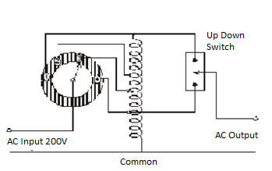

Figure 3 Basic Manual Voltage Stabilizer with up-down switch

**WORKING**

Auto-transformer is the main component of a manual voltage stabilizer auto transfer is a winded transformer with taps at secondary and is winded on core of conducing material. There are many taps on secondary It has single winding that acts as primary as well as secondary. It has common terminal to both primary and secondary.AC voltage is supplied between common terminal and the taps. Different voltages at output of auto transformer can be taken out. These voltages change according to the change in input voltage. Similarly as input voltages the required out from output voltages are taken in between the common terminal and the taps. When output voltage is not equal to the desired voltage of 220 volt, then output voltage is set to desired voltages by rotating the switch. Since output voltage is manually monitored and regulated that’s why it is called manual voltage regulator. It has two basic configurations:

* Without up-down switch
* With up-down switch.

**DISADVANTAGES**

* This type of voltage regulation almost discarded now because of its manual switching which is very time consuming and requires a lot of man power.

### 2.1.4 COMPARISON OF VOLTAGE STABILIZERS

**Table 2.1 Different voltage stabilizer comparison**

|  |  |  |  |
| --- | --- | --- | --- |
|  | Switching Speed | Switching time | Stability |
| Relay base voltage stabilizer | 200-500ms | 15KHz | 2% |
| Servo base voltage stabilizer | 500-1000ms | 10-15KHz | 2% |
| Solid state and static voltage stabilizer | 20-30ms | 20 KHz | 1% |

## 

## 2.2 RELATED WORK AND MARKET SURVEY

Following are the recently available voltage stabilizers in market and their specifications

**Table 2.2.1 Technical parameters of D&C 10KVA voltage stabilizer**

|  |  |
| --- | --- |
| Output capacity | 10 kVA |
| Efficiency | 90% |
| Rated power | 0.5-5 kVA |
| Input voltage range | 160-240 |
| Voltage stabilization precision | 220±4%, 110±4%, |

**Table 2.2.2 Technical parameters of solid 3KVA servomotor type single phase ac AVR**

|  |  |
| --- | --- |
| Output capacity | 3 kW |
| Efficiency | 90% |
| Stability time | <0.5s (input voltage change within 10%) |
| Input voltage range | 160-250 |
| Voltage stabilization precision | 230±3%, 220±3%, 110±3%, |

**Table 2.2.3 Technical parameters of CKEN 15KVA voltage stabilizer**

|  |  |
| --- | --- |
| Output capacity | 15 kVA |
| Efficiency | 90% |
| Rated power | 0.5kVA-3kVA |
| Input voltage range | 160-250,120-250, 90-250 |
| Voltage stabilization precision | 220 /110±4% |

# 3. REQUIREMENTS SPECIFICATION

The Non-functional and Functional Requirements are distributed into various groups based on objectives and relations, requirements and specifications Each requirement is assigned a name and the details accordingly are mentioned in the table

The Requirements consists of two types, the two types are explained as follow:

**Requirement Type:** There are two main types of requirements:

**FR**- Functional Requirement

**NR**- Non-Functional Requirement

**Functional Requirement:** A functional requirement explains what a system should do or provide to the users. They include description of the required functions and details of those functions.

**Non-Functional Requirement:** A non-functional requirement explains the performance characteristic of a particular system. It tells how a system would behave and what are the constraints put on a system and how it will behave under it.

A table has been represented to elaborate several requirements of the project which consist of two fields as mentioned below:

**Name:** This field contains the name of the requirements.

**Details:** This field contains the requirement description

The functional requirements are further categorized each having its own importance

## 3.1. DESIGN REQUIREMENTS

**Table 3.1 Design requirements of system**

|  |  |
| --- | --- |
| **Name** | **Details** |
| Platform | Microcontroller |
| Language | C/C++ |
| Compiler | HiTECH or CCS,mikroC Compilers |
| Usability | Fast switching Voltage stabilization, Solid state Voltage stabilization |
| Portability | Yes, This small scale prototype is portable and can be used for specific range of voltage stabilization |
| Transformer | Auto transformer or transformer with multi taps |

## 3.2. DELIVERABLES

**Table 3.2 Deliverables of project**

|  |  |
| --- | --- |
| **Name** | **Details** |
| Delivery | The system development process and deliverable documents shall conform to the process and deliverables defined in the document  “CIIT-CE-02H Degree Project Student’s Handbook” |
| Standard | The standard of the project is undergraduate level |

## 

## 3.3. SAFETY AND SECURITY

**Table 3.3 Safety and security of project**

|  |  |
| --- | --- |
| **Name** | **Details** |
| Security | This a final year degree project having not much restrict risks and security requirements however it should be dealt with care because of its an electrical appliance |
| Ethical | The modules used in this project are not used but have been taken reference from other projects |
| Legislative | The device is completely designed without infringing any copyrights. References have been mentioned from where help has been taken |
| Safety | This is a degree project it does not have any safety issue however if the voltages exceed or lessen the specific voltage regulation range there is a safety circuit installed that will turn off the voltage stabilizer and it will also notify by a buzzer. It should be placed in dry environment as it has electrical components and complex circuitry |

## 

## 3.4. AUTOMATION

The application is intended to regulate voltages from 170-270 Volts

**Table 3.4 Automation of project**

|  |  |
| --- | --- |
| **Name** | **Details** |
| Device Automation | Automation of the device should be able to regulate voltages in specific range to optimum voltages(220 V) for an appliance without Human Intervention |
| Voltage regulation | Voltage regulation will be done with triacs fed by optocoup-lers and controlled by microcontroller |
| Transformer | Transformer with 10 taps is used with the difference of 10 volt tap from 170 V to 270 V on secondary side |
| Sensor | Implementation of hall effect current Sensor |
| Limitations | If the voltages exceed or lessen the specific voltage regulation range (170 V to 270 V), there is a safety circuit installed that will turn off the voltage stabilizer and it will also notify by a buzzer. This is done for the safety of voltage stabilizer and output load |
| LCD  Interfacing | Attaching two LCDs to monitor the input and output voltage and current measurements |

## 3.5. FUNCTIONALITY

**Table 3.5 Functionality and major components of project**

|  |  |
| --- | --- |
| **Name** | **Details** |
| Source Code | Microcontroller contains the source code which is downloaded on it |
| Sensor Functionality | Hall effect sensors responsible measuring current at input and output side |
| Opto-couplers | Opto-couplers are used for isolated coupling of micro controller pins and triacs circuit. |
| Transformer | Transformer will take the input main supply and on secondary tapings it will be connected with anode of triacs |
| Triacs | Triggering of semiconductor devices triacs is controlled by microcontroller |

# 4. PROJET DESIGN

The project design constitutes of project methodology and design description.

## 4.1. METHODOLOGY

The aim of this project is to provide the load with stabilized voltage of 220 V ac. Voltage stabilizer acts as an intermediately device between input mains and load. This is done by interfacing different electrical components.

First of all, the input mains of 220V ac (rms), with 50 Hz frequency is fed to multi tap transformer and microcontroller. As we know that microcontroller cannot bear a voltage above 5 volts DC, therefore we need to step down and rectify this input supply to the limit of operating voltage required for microcontroller. In our project this is done by an auxiliary supply which we have designed for the sole purpose of powering microcontroller, LCDs, octocouplors and triacs. Now when the main is fed to primary side of transformer, the input ac voltage is induced to the secondary side which is connected with the load through different triacs. Now these triacs play an important part in stabilization of the voltage across the load. Optocouplors are a deriver circuits for these triacs and these optocouplors are further connected with the microcontroller.

Now whenever the input voltage goes out of the stabilized voltage limit of 220V±4%, across the load, it, at the same time, is fed to the microcontroller using a voltage sensor, microcontroller compare this input with required constant output of 220 V ac and decides that whether the input supply is needed to be stepped up or stepped down, on the basis of that decision it triggers the targeted triac using optocouplor. These triacs act like a switch between the load and secondary tapings of the transformer. In our case we have tapped the transformer at 12 different voltages ranging from 170 V to 270V when the input mains are stabilized at 220V.

Now for example if the voltage on the secondary side is 170 V, then the controller after reading the input voltage would trigger that specific triac that would connect that specific tap to the load on which we would get a voltage of 220V±4%, keeping all the other triacs off. Hence the load will keep on receiving a stabilized supply of 220V±4% no matter the voltage on the input side. But we have to keep this in mind that stabilization limit for our voltage stabilizer is 160V-270V. Any voltage level out of these limits would not be stabilized at 220V±4%. We have designed our project in such a way that if a voltage level out of these limits appears at input mains, the controller after detecting it would simply cutoff the supply to load by triggering all the triacs off, since such voltage levels would be hazardous for our device and can damage the transformer which is the most integral part of our stabilizer. The block diagram explains the above mentioned methodology.

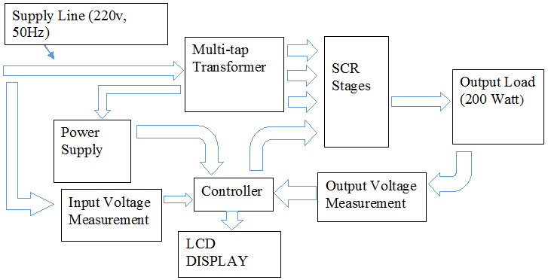

Figure 4 Block Diagram

### 4.1.1 AUXILARY POWER SUPPLY

A power supply can be seen as an energy source to power any electrical equipment or electrical load. Its primary function, usually, is to convert chemical o mechanical energy to electrical energy. The nature or type of power supply can vary according to the load it’s going to power. Its capacity also depends on the amount of electrical energy required by the load. Some power supplies are discrete, stand-alone devices, whereas others are built into larger devices along with their loads, the latter ones are also known as auxiliary power supplies. Auxiliary power supplies are used where the nature of the electrical load is such that it requires two different kinds of input powers to energize its different parts which are separate from each other. For example one part of electrical equipment may require a power while the other part may operate on dc source. Usually the power supplies which are needed to power electrical equipment, operating on dc voltage and it is a p/art of a larger equipment, are regarded as auxiliary supplies. Same is the case in our project, since our project is made to stabilize voltage across ac loads using multi-tap transformer and microcontroller. Therefore two different power supplies are needed. An AC supply to power load through transformer and a dc supply to power microcontroller and LCDs. Therefore we have used a  self-designed secondary power supply to power these dc passive elements. Our auxiliary supply takes the power from the same ac source which powers the load and converts this into a step down dc power to energize dc equipment. The secondary power supply in our project is used to supply power to components that operate on 5v dc. Our auxiliary supply consists of a 12V ac tap from the transformer, a bridge rectifier and a 7805 voltage regulator.

**BRIDGE RECTIFIER*:*** So here we needed to convert ac voltages to dc voltages. For this purpose a tap of 5 and 12 v is taken from secondary side and fed to a full wave bridge rectifier.

A bridge rectifier consist of four diodes in a bridge arrangement which provides the same polarity as input current to output current. It is used to convert an alternating AC input into a direct DC output. The four diodes are arranged in a bridge configuration to achieve full wave rectification. In Project Bridge rectifier converts the Ac current to Dc current and is used to power micro controller, LCDs and sensors as they operate on direct DC. The rectifier has an output of 5 Volts and 12 volts.

Input: 5 Volts AC

Output: 5 Volts DC

The full wave bridge rectifier has four diode arranged in a bridge circuit to rectify the full wave. Two diodes in series conduct at a time, the diodes need half [reverse break voltage](http://www.learnabout-electronics.org/Semiconductors/diodes_21.php#VRWM) ability of diodes use for half and full wave rectification. The bridge rectifier can be built from separate diodes or a combination of diode in bridge topology. In each half cycle, different pair of diodes conducts at a time, but the current polarity remains the same throughout the cycle.

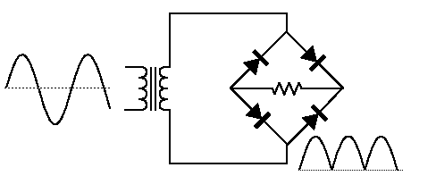

Figure 5 Bridge Rectifier Circuit

**VOLTAGE REGULATOR:** Dc output is then regulated using 7805. The converted voltages from input may have fluctuation so that’s why they are needed to be regulated. The voltage regulator IC maintains the voltage level at the output. 7805 provides the regulated 5 volts at the output. Capacitor o the suitable value can be connected at the output with respect to the voltage level

**IC 7805** is a **5V Voltage Regulator** that maintains the output to 5 volts and takes and draws regulated supply. The maximum value input value of voltages that can be regulated is 35 volts. It can provide a constant voltage flow of 5 volts for the input voltages of up to 35 volts. For the voltages near 7.5volts there is no need of heat sink the heat is absorbed. If the voltage input exceeds more than hear is exhaust from the voltage regulator it regulates a steady output of for the input range (7.2V - 35V). Hence to avoid power losses voltages should be maintained at 7.2 volts.

### 4.1.2. INPUT AND OUTPUT VOLTAGE AND CURRENT MEASUREMENT

Input and output voltages and currents are very important to monitor as they depict that the stabilization of voltage is achieving or not. Since we are making our project on the product scale, so it necessary that these readings should be shown to the end users so they can be kept aware of their input voltage and whenever a voltage spike comes they would know by simply looking at LCDs and they would also know that there device is working by just looking the stabilized output voltage. In order to observe that whether the output voltage is stabilized we need to first measure them and currents too.

**VOLTAGE MEASUREMENT:** To measure the input voltage we would rely on microcontroller, as we know that microcontroller can only take readings up to 5V dc and the voltages it has to measure are in the range of 160V to 270V ac. We have done this by taking a tap of 5V ac from the transformer and then rectifying it to 5V dc and then it would be fed to microcontroller. The rest of the process of measuring is done by controller. As we know that our controller can take analogue values it would then convert these readings to different levels represented by whole numbers. Whenever the voltage on the primary of transformer changes the voltage induced on the secondary side would also be changed. Since there are different tapings on the secondary side therefore voltage on these taps would appear according to the input voltage on primary side. Same would be the case with the 5V ac tap which is used for input voltage measurement. The voltage on this tap would also be changed according to the input voltage and this 5V is the normalized value, only appearing on this tap when the voltage on the primary side is 220V. We would take the voltage from this tap and rectify it with the help of a bridge rectifier to attain

5V dc. Then this value is fed to a voltage divider circuit from which it would be fed to microcontroller. Since there is a built in ADC (analogue to digital convertor) in the controller which would convert these analogue values to different digital levels, each corresponding to a certain analogue value. Now we have programmed the controller in such a way that it would convert these values to actual input voltages and would use these readings for both comparing of input and output voltage and showing these values on LCD. As our device is working between 160V to 270V so we have, in advance, programmed the controller to assign each reading a different digital value. As the voltage on the input side changes the voltage on the 5V tap also changes accordingly so does the voltage fed to controller and for each value a different digital value would appear in controller which then would converted to the actual value by the calculations done in programming.

We would repeat an analogous process to above, in order to attain output voltage. we would first design a voltage divider to get a stepped down voltage, since the output voltage is of the range 220±5 V, then it would be rectified and fed to the controller for processing. Controller will do the same processing as for input voltage calculation and would display the final output value on the LCD.

**CURRENT MEASUREMENT**: For input, output current measurement we are using CT (current transformer) based sensors. On a CT based sensor is attached in series with the primary of transformer, similarly on the output side another CT sensor is connected with load in series. The **Current Transformer ( C.T. ),** is a type of “instrument transformer” that is designed to produce an alternating current in its secondary winding which is proportional to the current being measured in its primary.

Now as we know that in current transformer there are large no of turns on secondary winding as compared to primary winding. Since the power remains same on both sides of transformer, therefore the turn ratio of a CT is usually of the order of 1:20. This means that if a current of 100 amps flow in primary side we would get a secondary current of 5 amps which then can be easily measured using a simple resistance.

We would attach a resistance in series with this stepped down secondary current. The value of the resistance would be set as the voltage appear across it can be fed to microcontroller. This voltage would be proportional to secondary current.

Vs = Is * R

Controller would read this voltage from one of its analogue pins and then it would process it to get the original input current (current on primary side of CT) as following

* Is = Vs / R
* Ip = Is (Np/Ns)

The output current would be measured as same as above mentioned process, by a CT sensor which is attached in series with load.

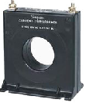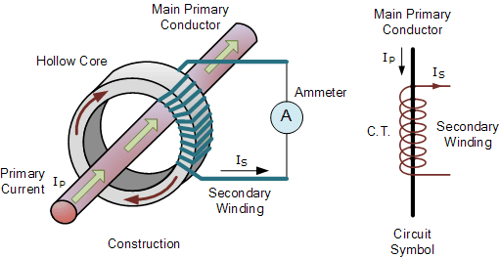

Figure 6 Construction Schematic and Current transformer

### 4.1.2 CONTROLLED SCR TRIGERRING

Microcontroller precedes the SCR stages. SCR triggering is controlled by micro controller. As we can see that Vcc pin of the optocoupler deriver is connected with microcontroller. We can see that the optocoupler consists of two isolated circuits. The circuit on the left hand side contains a bidirectional scr, whose one terminal is connected with load and triac while the other terminal is connected with the triac. The load is connected in series with triac and ac mains. An RC branch which acts as a snubber is connected in parallel with the triac.

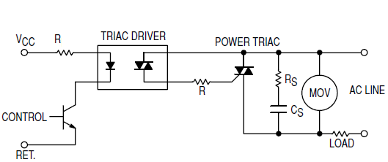

Figure 7 Trigerring Circuit

Now whenever microcontroller decides to trig a triac OFF or On, it just sends a DC pulse at Vcc terminal of the opto coupler, as the current flows from the diode on the left side of the optocoupler, due to the photoelectric effect, it triggers the bidirectional SCR on right side of the optocoupler . Now when this bidirectional diode switches ON, it connects the input ac supply to the gate of triac, which results in triggering it. In this way the stepped up or stepped down ac supply coming from the desired tapping at the secondary of transformer comes right down at the load. Hence by turning ON desired triacs, we achieve to keep a stabilized voltage across the load.

Now whenever the controller decides that the triggered scr stage is no longer needed, it simply sends aa negative pulse at Vcc triggering Off the optocoupler which in results turn that specific triac OFF.

## 4.2 DESIGN DESCRIPTION

Following are the modules constituting the product to be developed. Please note that we are documenting only the salient properties and methods of each module to keep the description simple and more readable.

### 4.2.1. PIC MICROCONTROLLER

PIC18F4550 is one of the most commonly used having most featured microcontroller from Microchip. This controller is widely used for experiments and in modern systems because of its low cost, wide range of task for different application, high quality and high frequency, and ease of availability and use. It is ideal for applications such as power and machinery control applications, measurement devices and it is also used for experiments and study purpose, and so on. The PIC18F4550 feature all the parts which modern microcontrollers normally have except the additional board and safety circuitry. The figure of a PIC18F4550 controller is shown below.

PIC18F4550 is an 8-bit microcontroller of family of PIC 18F. PIC18F family is based on 16-bit instruction set architecture. It consists of 32 KB flash memory, 256 Bytes EEPROM and 2KB SRAM. It is a 40 pin PIC controller that consists of 5 input output ports (PORTA, PORTB, PORTC, PORTD and PORTE). (PORTB and PORTD) have 8 pins to receive and transmit 8-bit input output data. The remaining ports have different numbers of pins for input output data communications. PIC18F4550 can also work on internal and external clock sources. It can work on a different range of frequency from (31-48) MHz PIC18F4550 has 4 in-built timers. There are many inbuilt peripherals like comparators, ADC etc. in this controller. PIC18F4550 is an advance microcontroller which is equipped with enhanced and new protocols of communication like EUSART, SPI, I2C, USB etc.

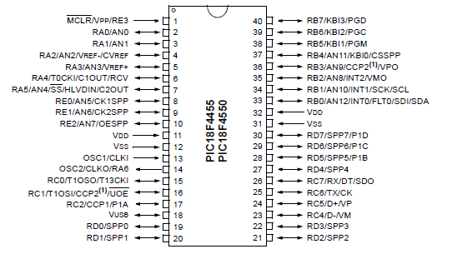

Figure 8 PIC Pin Configuration

#### 4.2.1.1. FEATURES

The PIC18FXX series has more advanced and developed features when compared to its other series. The important features of PIC18F4550 series is given below.

* . High performance RISC CPU.
* All single cycle instructions except for program branches which are 2 cycles.
* Operating speed: clock input (200MHz), instruction cycle (200nS).
* Up to 368×8bit of RAM (data memory), 256×8 of EEPROM (data memory), and 8k×14 of flash memory.
* 8 level deep hardware stack.
* Interrupt ability (up to 14 sources).
* Different types of addressing modes (relative addressing modes, direct and indirect).
* Power on Reset (POR).
* Power-Up Timer and oscillator timer start up.
* Low power- high speed CMOS flash or EEPROM.
* Fully static design.
* Wide operating voltage range 2.0 Volts to 5.56 volts.
* High sink and source current of 25mA.
* Commercially, and extended temperature ranges.
* 10000 times erase and write cycle enhanced memory.
* 100000 times erase and write cycle data EPROM memory.
* Self-programmable under software control.
* In-circuit serial programming and in-circuit debugging ability.
* 5V DC supply for programming of serial circuit
* WDT for reliable operation with own RC oscillator.
* Programmable protection of code.
* Power saving sleeping modes.
* Oscillator selector options

#### 4.2.1.2. ADVANTAGES

* They are reliable .Malfunctioning and problems in PIC microcontroller percentage are very least. And performance of the PIC is fast because of using RISC architecture.
* Power conception of PIC is very less as compared to other microcontrollers. In programming and interfacing point it is easy to interface components with it, also we can connect analog devices direct without any additional circuitry and utilize them. Coding is also easy as compared to other microcontrollers.
* Easily programmable
* One of the major advantages is that each pin is only shared between two or three functions so it’s easier to decide what is the pin function whereas as other microcontrollers as different functions up to 5 on a single pin

#### 4.2.1.3. APPLICATIONS

* Light sensing &devices control
* Temperature sensing and device control
* Fire detection &device safety
* Industrial instrumentation devices
* Process and power control devices
* Industrial instrumentation devices
* Volt Meter
* Measuring revolving objects
* Current meter
* Hand-held metering system

### 4.2.2 OPTOCOUPLER

Opto-isolators or Opto-couplers, are made of a light emitting device, and a light sensitive device, all contained up in one package, without any electrical connection between the two, just a beam of light. The light emitter is nearly always an LED. The light sensitive device might be a photodiode, phototransistor, or more esoteric devices such as thyristors, TRIACs etc.The optocoupler usually used in switch mode power supply circuit in many electronic equipment. They are mainly used for switching TRIACS that’s why they are also regarded as driving circuitry for TRIACS. It is connected in between the primary and secondary section of power supplies. The opto-coupler application or function in the circuit is to

1. Monitor high voltage
2. Output voltage sampling for regulation
3. System control micro for power ON/OFF
4. Ground isolation

This is the same principle used in Opto−Diacs, the Opto-Diacs are available in form of ICs and can be implemented using a simple circuitry. We have to simply provide a small pulse at the right time to the Light Emitting Diode on the left side. The light produced by the LED activates the light sensitive properties of the diac and the power across the diode is switched on. It means that if a voltage is applied across the diode, a current can flow through it when it is ON. The isolation between the low power and high power circuits in these optically connected devices is typically several thousand volts.

#### 4.2.2.1 PIN DESCRIPTION

* Pin 1: Anode
* Pin 2: Cathode
* Pin 3: No connection (NC)
* Pin 4: Main terminal
* Pin 5: No connection (NC)
* Pin 6: Main terminal

#### 4.2.2.2 FEATURES

* 400 V Photo-triac driver output
* Gallium-Arsenide-Diode Infrared Source and Optically-Coupled Silicon triac driver
* High Isolation 7500 V Peak
* Output Driver Designed for 220 Vac
* Standard 6-terminal plastic DIP

There are many applications of MOC3021 such as solenoid/valve controls, lamp ballasts, interfacing microprocessors to 115/240 Vac peripherals, motor controls and incandescent lamp dimmers.

#### 4.2.2.3 APPLICATIONS OF MOC3021

The most commonly used is an opto-coupler MOC3021 with an LED diac type combination. Additionally while using this with microcontroller and one LED can be connected in series with MOC3021, LED to indicate when high is given from micro controller such that we can know that current is flowing in internal LED of the opto-coupler. When logic high is given then the current flows through the LED from pin 1 to 2. So in this process LED light falls on DIAC causing 6 and 4 to close. During each half cycle current flows through gate, series resistor and through opto-diac for the main thyristor / triac to trigger for the load to operate.

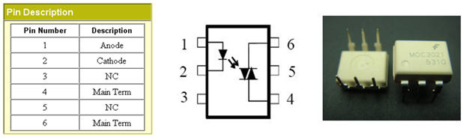

Figure 9 Optocouplers

### 4.2.3 TRIACS

Triacs are suitable for general purpose AC switching. It can be used as an ON/OFF function in applications such as induction motor, static relays, starting circuits, heating regulation or for phase control operation in light dimmers and motor speed controllers, etc. Triacs (BTA08) which we have used in our project are good for on load ac switching. Since they are used for ac switching they basically diacs from which current can pass in both directions. A high ac voltage (0-600V) can be applied at both of TRIAC’s anode terminals. Current will only pass through it as long as a DC pulse is provided at its gate terminal.

#### 4.2.3.1 FEATURES

* Junction temperature (Tj): -40 to 110°C
* High DV/DT rate with strong resistance to electromagnetic interference
* With high ability to withstand the shock loading of large current
* Especially recommended for use on motorcycle, solid state relay, power charger and E-tools
* Environment-friendly compliant with RoHS Directive, UL certification and Pb-free
* High surge current capability

#### 4.2.3.2 SPECIFICAIONS

* Non Repetitive On state current is 8 A
* Rated repetitive Off state voltage is 600 v
* Off state leakage current is 5uA
* On state voltage is 1.55 v
* Holding current is 15 mA
* Gate trigger voltage is 1.3 v
* Gate trigger current is 10mA
* Maximum operating voltage is 125 C
* Packing is tube
* Current rating is 8 A
* Insulating voltage are 2500 Vrms

# Image result for triac

Figure 10 Triac schematic

# IMPLEMENTATION

We have implemented the suggested design, working through following stages. As our project is an interface of different separate design blocks so in this chapter we would discuss their functioning and practical implementation.

## 5.1 DEVELOPMENT STAGES

Following were the discrete phases we have experienced incrementally to realize our product in the given time:

### 5.1.1 TRANSFORMER SPECIFICATIONS

Transformer is a major component of our project. Transformer is a simple device used for either stepping-up or stepping down an applied AC input through magnetic induction in between its two windings. In our project transformer is an intermediately device between AC input and load, since it is providing a regulated voltage on either of its taps which are all connected to the load resulting a stabilized voltage across the load. We have selected our transformer on the basis of our load specifications. Since we are developing our stabilizer for mini fridges ranging from 80W to 150W, therefore keeping these ratings in view, we have selected a transformer of 250VA. Our transformer has following major specifications.

**TAPINGS:**Basically transformer we have used is a step up transformer giving a 270V output when input is at 220V.Our transformer has a total of 17 taps. 12 of these taps are used for voltage regulations which are connected with the load through triac stages. Voltages on these taps are ranging from 170V to 270V, each tap is at a voltage difference of 10V from its predecessor, starting from 170V. Remaining 5 taps includes a common ground, a 5V and 12V tap with their individual grounds. The tap with the 12V is used for supplying power to the microcontroller and LCDs. The voltage from this tap is rectified to 12V DC and then regulated at two different voltage levels of 5V and 12V to power microcontroller and LCDs using voltage regulators LM7805 and LM7812 respectively. Whereas the 5V tap is used by controller to read input AC voltage.

**NO. OF TURNS**

These are the turns on primary and secondary side of transformer

**Table 5.1.1.1 Number of turns of transformer**

|  |  |
| --- | --- |
| Primary Side | 520 |
| Secondary Side | 629 |

**TPV (TURNS PER VOLTAGE)**

It is a factor representing the no of turns which has a voltage difference of 1V across them. Actually TPV is measured earlier to When the voltage is stable at 220V on input side and 270V on the output side then

TPV= No of turns on secondary side */* Max. Voltage at secondary side

TPV= 629 / 270 = 2.33

**CORE AREA**

Core area = 1.5 * 2 = 3 square inches

**CORE TYPE**

The core of our transformer is a mixture of silicon, iron and carbon having a flux density of 1.3 Weber/sq.m

**WIRE GAUGES**

**Table 5.1.1.2 Wire gauge of transformer**

|  |  |  |  |  |
| --- | --- | --- | --- | --- |
| Wire gauge | Conductor Diameter mm | Ohm per km | Max. amps | Max. Frequency |
| 23 (primary) | 0.57404 | 66.7808 | 4.7 | 53kHz |
| 24(secondary) | 0.51504 | 84.1976 | 3.5 | 68kHz |

All readings are in accordance with American wire gauge standards.

**PRIMARY CURRENT:** Maximum amount of primary current that can pass through the primary winding of transformer and is supported by the primary wire gauge is as follows

Primary current = (Secondary Volts × Secondary Current) ÷ (Primary Volts × Efficiency)

The average value for the efficiency of any transformer may be presumed to be 0.9 as a standard figure.

Primary current = (270×3.5) ÷ (220 ×0.9) = 4.77A

In NO-LOAD condition the current which is supplied from the source is used for two purposes, as a result it has two components which serve for two different purposes. The major component of the primary current is the current which is used for magnetizing the transformer core and the second component is the current which compensates for the core losses (eddy currents and hysteresis). Now one of these components is in 90 degree lag with the input voltage( which is magnetizing current and also the major component) while the other component( that compensates for core losses and is minor one) is in phase with the applied voltage. Since this component is in phase with the applied voltage, that’s why the actual phase of overall current is little less than 90o lag of applied voltage.

* An in-phase current, IE which compensates for the core losses (eddy current and hysteresis).
* A small current, IM at 90o to the voltage which sets up the magnetic flux in the core.

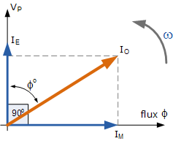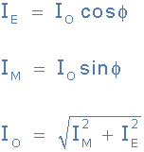

Figure 11 Eddy Current, magnetizing current and their relationship

### 5.1.2 INPUT VOLTAGE MASUREMENT

To measure the input voltage we would rely on microcontroller, as we know that microcontroller can only take readings up to 5V dc and the voltages it has to measure are in the range of 170V to 270V ac. We have done this by taking a tap of 5V ac from the transformer and then rectifying it to 5V dc and then it would be fed to microcontroller. The rest of the process of measuring is done by controller. As we know that our controller can take analogue values it would then convert these readings to different levels represented by whole numbers. Whenever the voltage on the primary of transformer changes the voltage induced on the secondary side would also be changed. Since there are different tappings on the secondary side therefore voltage on these taps would appear according to the input voltage on primary side. Same would be the case with the 5V ac tap which is used for input voltage measurement. The voltage on this tap would also be changed according to the input voltage and this 5V is the normalized value, only appearing on this tap when the voltage on the primary side is 220V. We would take the voltage from this tap and rectify it with the help of a bridge rectifier to attain 5V dc. Then this value is fed to a voltage divider circuit from which it would be fed to microcontroller. Voltage divider is designed as that the supply from 5V tap is fed to full wave bridge rectifier to get 5V dc from there these 5 volts are set on a variable resistor to get around 2.76V when the voltage on the input side is 220V. We would then make table of the voltage values across variable resistor, each corresponding to a unique value on the primary of transformer or ac mains. A resistor of 1k is connected in parallel to the 5V tap to stabilize the voltage across the variable resistor so that it could be fed to microcontroller. This was quite a problem we faced, because voltage wasn’t stabilizing at a constant value before connecting the 1k resistor.

Since there is a built in ADC (analogue to digital convertor) in the controller which would convert these analogue values to different digital levels, each corresponding to a certain analogue value. Now we have programmed the controller in such a way that it would covert these values to actual input voltages and would use these readings for both comparing of input and output voltage and showing these values on LCD. As our device is working between 160V to 270V so we have, in advance, programmed the controller to assign each reading a different digital value. As the voltage on the input side changes the voltage on the 5V tap also changes accordingly so does the voltage fed to controller and for each value a different digital value would appear in controller which then would converted to the actual value by the calculations done in programming.

### 

### 5.1.3 OUTPUT VOLTAGE MEASUREMENT

### We would repeat an analogous process to above, in order to attain output voltage. We would first design a voltage divider to get a stepped down voltage. In voltage divider there are two resistors connected in series, one has a value of 2M ohm while the other one is a variable resistor whose value is set at 0.96M ohm. We stepped down ac voltage across the load and feed this stepped voltage to the bridge rectifier, which is 17v in case of 220v normalized voltage at the load. Then we feed these 17V to the bridge rectifier to make them dc, then we again step these 17V dc to 2.8V using a voltage divider. This voltage divider is just comprised of a variable resistance whose value is again set at 0.96V. Since the output voltage across the load would vary in the range of 220±5 V, we would then again make a table of the voltage values across variable resistor, each corresponding to a unique value across the load. Then these values would be fed to the controller for comparing and measuring the voltage across the load. Controller will do the same processing as for input voltage calculation and would display the final output value on the LCD.

### 5.1.4 INPUT CURRENT MEASUREMENT

For input, output current measurement we are using CT (current transformer) based sensors. On a CT based sensor is attached in series with the primary of transformer, similarly on the output side another CT sensor is connected with load in series. The **Current Transformer ( C.T. ),** is a type of “instrument transformer” that is designed to produce an alternating current in its secondary winding which is proportional to the current being measured in its primary.

Now as we know that in current transformer there are large no of turns on secondary winding as compared to primary winding. Since the power remains same on both sides of transformer, therefore the turn ratio of a CT is usually of the order of 1:20. This means that if a current of 100 amps flow in primary side we would get a secondary current of 5 amps which then can be easily measured using a simple resistance.

We would attach a resistance in series with this stepped down secondary current. The value of the resistance would be set as the voltage appear across it can be fed to microcontroller. This voltage would be proportional to secondary current.

Vs = Is * R

Controller would read this voltage from one of its analogue pins and then it would process it to get the original input current (current on primary side of CT) as following

* Is = Vs / R
* Ip = Is (Np / Ns)

### 

### 5.1.5 OUTPUT CURRENT MEASUREMENT

The output current would be measured as same as above mentioned process, by a CT sensor which is attached in series with load.

### 5.1.6 CONTROLLED SCR TRIGERRING

Microcontroller precedes the SCR stages. SCR triggering is controlled by micro controller. As we can see that Vcc pin of the optocoupler deriver is connected with microcontroller. We can see that the optocoupler consists of two isolated circuits. The circuit on the left hand side contains a bidirectional scr, whose one terminal is connected with load and triac while the other terminal is connected with the triac. The load is connected in series with triac and ac mains. An RC branch which acts as a snubber is connected in parallel with the triac.

Now whenever microcontroller decides to trig a triac OFF or On, it just sends a DC pulse at Vcc terminal of the opto coupler, as the current flows from the diode on the left side of the optocoupler, due to the photoelectric effect, it triggers the bidirectional scr on right side of the optocoupler . Now when this bidirectional diode switches ON, it connects the input ac supply to the gate of triac, which results in triggering it. In this way the stepped up or stepped down ac supply coming from the desired tapping at the secondary of transformer comes right down at the load. Hence by turning ON desired triacs, we achieve to keep a stabilized voltage across the load.

Now whenever the controller decides that the triggered scr stage is no longer needed, it simply sends aa negative pulse at Vcc triggering OFF the optocoupler which in results turn that specific triac OFF.

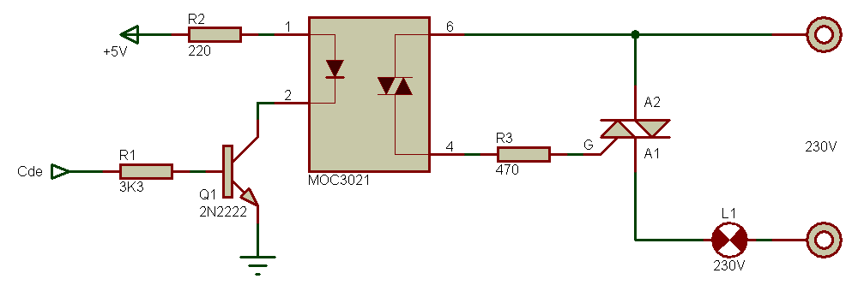

Figure 12 Optocouplers Driving Triacs

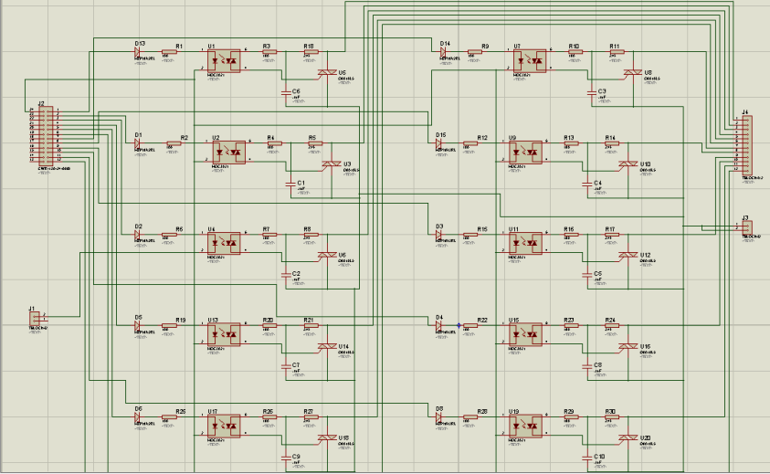

Figure 13 Proteus simulation of SCR stages

### 

### 5.1.7 PCB IMPLEMENTATION

A PCB is known as printed circuit board, it is a module which has component fixed on it from small components like resistances to beepers and radars even. PCB is composed of two major parts. One is known as substrate and the other is the deposit of conducting materiel which forms different circuits on the substrate. Substrate is the board on which copper or any other conducting materiel is usually deposited to form desired circuits. After this the different electronic components which are forming the desired circuit are placed on the substrate completing the desire circuit. The PCB layouts of the circuits are first formed using different software. In our case we are using ARES which is a built in tool in PROTEUS simulation software. Then this printed layout is placed on the substrate whose surface is covered with depositing of a conducting materiel. Then we iron our layout on the substrate as a result our desired circuit is printed on the PCB. We then wash our PCB in the ferric chloride solution which washes off all the copper depositing on the substrate except where our design is printed as a result only thing left on the substrate is copper linings making our circuit designed on PCB. We then place different electronic components on the PCB and solder them on PCB to make our circuit complete and working.

There are three major types of printed circuit board construction: single-sided, double-sided, and multi-layered. Single-sided boards have the components on one side of the substrate and copper wiring on the other side. In case our design required a large no of electronic components we then use a double layered PCB. Electrical connections on either side of the PCB are made by drilling holes in substrate at appropriate locations and soldering the inside of the holes with a conducting material. A multi layered PCB has a substrate made up of different layers. These layers are placed on each other and are separated from each other using insulations between them. Now different electronic components which are needed to be connected to different layers are placed on the either surface of substrate and are connected with the desired layers by drilling appropriate holes through the substrate to desired layer. This greatly simplifies the circuit pattern.

Components on the PCB are connected to different circuits using two different methods. The first and older one was “through hole” connection and the second and newer one is “surface mount technology”. In the “through hole technology” components are placed on one side of the PCB and after passing the thin wires and leads attached to them through drilled holes we solder these leads with the copper linings padded on the opposite side. Once they are soldered they are fixed at their respective places. In surface mount technology we have L-shaped or J-shaped legs which act as connectors and connects the electronic components directly with the PCB. A solder paste made of glue, flux, and solder is applied at the point of contact to hold the components in place till this paste is melted to make permanent connection in by heating it in an oven. In surface mount technology we have to deal the components with greater care in order to place them correctly, but it has the major advantage of eliminating drilling process which consumes a lot of time and effort and also it gets rid of the space consuming connection pads used in “through hole” technology. Both technologies are used today.

Following is the PCB layout for individual SCR circuitry in one package. We have used the trace of T30 for connections and via size depends on the components size The internal resistance of 30 mils via is 8.2 milliohms.

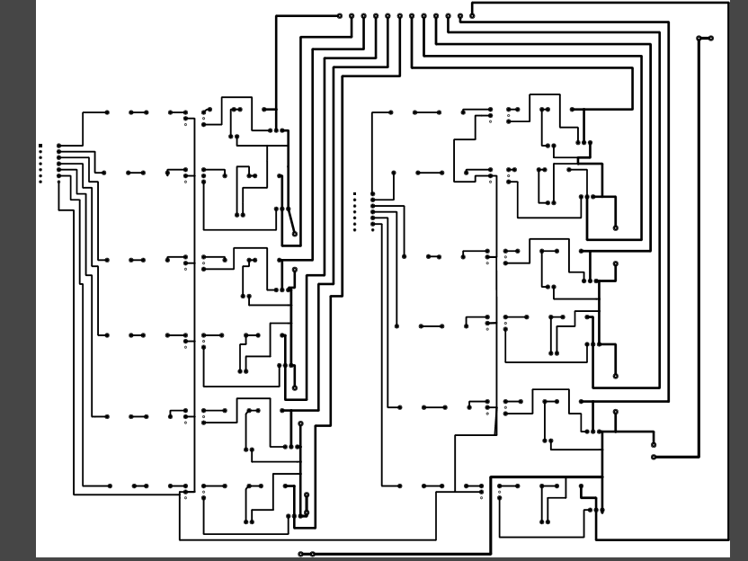

Figure 14 PCB for SCR circuit

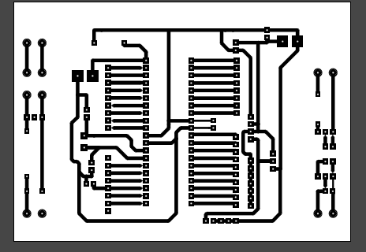

Figure 15 PCB for micro controller

### 

Figure 16 PCB for auxiliary power supply

### 5.1.8 SYSTEM INTEGRATION

First of all, the input mains of 220V AC (rms), with 50 Hz frequency is fed to multi tap transformer and microcontroller. As we know that microcontroller cannot bear a voltage above 5 volts DC, therefore we need to step down and rectify this input supply to the limit of operating voltage required for microcontroller. In our project this is done by an auxiliary supply which we have designed for the sole purpose of powering microcontroller, LCDs, octocouplors and triacs. Now when the main is fed to primary side of transformer, the input ac voltage is induced to the secondary side which is connected with the load through different triacs. Now these triacs play an important part in stabilization of the voltage across the load. Optocouplors are a deriver circuits for these triacs and these optocouplors are further connected with the microcontroller.

Now whenever the input voltage goes out of the stabilized voltage limit of 220V±4%, across the load, it, at the same time, is fed to the microcontroller using a voltage sensor, microcontroller compare this input with required constant output of 220 V ac and decides that whether the input supply is needed to be stepped up or stepped down, on the basis of that decision it triggers the targeted triac using optocouplor. These triacs act like a switch between the load and secondary tapings of the transformer. In our case we have tapped the transformer at 12 different voltages ranging from 170 V to 270V when the input mains are stabilized at 220V.

Now for example if the voltage on the secondary side is 170 V, then the controller after reading the input voltage would trigger that specific triac that would connect that specific tap to the load on which we would get a voltage of 220V±4%, keeping all the other triacs off. Hence the load will keep on receiving a stabilized supply of 220V±4% no matter the voltage on the input side. But we have to keep this in mind that stabilization limit for our voltage stabilizer is 170V-270V. Any voltage level out of these limits would not be stabilized at 220V±4%. We have designed our project in such a way that if a voltage level out of these limits appears at input mains, the controller after detecting it would simply cutoff the supply to load by triggering all the triacs off, since such voltage levels would be hazardous for our device and can damage the transformer which is the most integral part of our stabilizer. The block diagram explains the above mentioned methodology.

Here is a basic table showing voltage appearing on different taps for various inputs on ac mains and tap selection for stabilizing the voltage in the range of 220±5V.

**Table 5.1.8 Voltage appearing on taps and taps selection criteria**

|  |  |  |  |  |
| --- | --- | --- | --- | --- |
| ***INPUT VOLTAGE*** | 220 V | 210V | 230V | 160V |
| ***TAPS*** | - | - | - | - |
| Tap#12 | 160V | 150V | 170V | 100V |
| Tap#11 | 170V | 160V | 180V | 110V |
| Tap#10 | 180V | 170V | 190V | 120V |
| Tap#9 | 190V | 180V | 200V | 130V |
| Tap#8 | 200V | 190V | 210V | 140V |
| Tap#7 | 210V | 200V | 220V | 150V |
| Tap#6 | 220V | 210V | 230V | 160V |
| Tap#5 | 230V | 220V | 240V | 170V |
| Tap#4 | 240V | 230V | 250V | 180V |
| Tap#3 | 250V | 240V | 260V | 190V |
| Tap#2 | 260V | 250V | 270V | 200V |
| Tap#1 | 270V | 260V | 280V | 210V |
| ***TAP SELECTION*** | Tap#6 | Tap#5 | Tap#7 | Tap#1 |

# 

Figure 17 Proteus simulation of integrated circuit

# 6 FUNCTION TESTING

After integrating different parts of system. Testing was done individually of different modules and optocouplers were tested first using direct current at input and triacs were drived by it to check whether they conduct or not and whether they can switch according to the microcontroller

## 6.1 TESTING OF COMPONENTS

Testing of components was done to check whether if they are faulty are not. Testing of components is essential and because it makes less complexity while troubleshooting and testing the overall hardware design

### 6.1.1 TESTING OF TRIACS

Triacs are used to control current and triacs are three terminal semiconductor devices. Their bi-directional construction means that the current can flow through them in both directions. An acronym for Triode Ac Current, Triacs are commonly used for alternating current switching applications.

The three terminals of a triode are described as Terminal 1, Terminal 2 and the gate; Termianl1 and Terminal 2 serve as the current carrying terminals, while gate serves as a trigger where the triggering pulse is given.

* Testing of triacs is done by Unplugging the triac circuit and discharge the current of high capacitor.
* Then Set the multi meter to high resistance mode, which should read up to 100 ohms.
* Connecting the terminals 1 and 2 of triacs to the positive and negative probe of multi meter.
* Check the reading of multi meter that should be indicating high resistance
* Repeat the same process by setting the multi meter to low resistance mode.
* Check the gauge for a low resistance reading, indicating that the switch is on. If it is present, then the triac is in working condition and good to operate. Otherwise an abnormal reading would suggest if it’s faulty.

### 6.1.2 TESTING OF OPTOCOUPLERS

An optocoupler refer to as opto isolator that allows two individual circuits to exchange light signals and they yet remain electrically and physically isolated. This is usually done by using light to relay the signal to other circuit . The standard opto coupler circuit uses an LED on a phototransistor. The signal is applied to the LED, which then shines on the transistor. The amount of light transmitted from the diode is proportional to the signal, so the signal is thus transferred to the phototransistor. Optocoupler may also use SCRs, photodiodes, other semiconductor switch as an output.

The breakdown of optocoupler causes the circuit to:

* Blinking power
* No power
* Low power
* Unstable power
* Shutdown power

Since the internal layout of optoisolator, checking theIC is similar as checking the normal transistor and LED

To check optoisolator accurately, an analog multimeter is needed. Check the LED 2 times using the 1 ohm and 10k ohms range. It should only have one reading on both times. If it has 2 readings then there is a fault or maybe internal LED is being short.

The testing method is exactly similar as checking a normal diode. The LED is mainly connected to the internal pin 1 and 2 of the IC. For checking the phototransistor, set the meter to the 1 ohm and put black probe to the base of transistor and red probe to emitter and the collector. It should also show two readings. Then move the black probe to collector and the red probe to emitter and base. It should not show any reading on the multi meter. Lastly put the black probe to emitter and the red probe to collector and base. Again it should not show   
any reading. Now set meter to 10k ohm to measure the emitter and collector. It should not show reading on one way or it may show a small reading, that mean the meter needle move a little up from the zero scale of the meter.

### 6.1.3 SYSTEM TESTING

Similarly system was tested at different stages.

For current measurements, current sensor was tested using its circuit

For voltage measurements, dry test was done on proteus simulation and afterwards on hardware

System was tested using an output load and regulation details were measured through LCDs

## 6.2 RESULTS

For our voltage regulator, the input voltage variation andthe operational range is from (170 to 270 V). This means that the scr maintaining the output voltage constant would be triggered only when the input voltage is within 170 and 270 V. In project, the input voltage variation is done manually using a variable autotransformer called variac. Using the measurements obtained, regulation is determined by use of formula

Load regulation % = (VnL-VfL)/VfL

VnL=Voltage with no load

VfL=Voltage with full load

The voltage regulation in percentage related to the input voltage variation is presented according to load of 80 watt mini size fridge

**Table 6.2 Results of testing**

|  |  |  |  |
| --- | --- | --- | --- |
| AVR Input Voltage  (V) | AVR output Voltage No load  (V) | AVR output Voltage on load  (V) | Regulation  (%) |
| 160 | 220 | 216.43 | 98.3% |
| 170 | 220 | 216.3 | 98.28% |
| 180 | 220 | 217.7 | 98.94% |
| 190 | 220 | 217.9 | 99.39% |
| 200 | 220 | 218.68 | 99.47% |
| 210 | 220 | 219.43 | 99.74% |
| 220 | 220 | 219.56 | 99.79% |
| 230 | 220 | 221.73 | 99.21% |
| 240 | 220 | 221.67 | 99.24% |
| 250 | 220 | 222.68 | 98.79% |
| 260 | 220 | 223.45 | 98.45% |
| 270 | 220 | 223.98 | 98.22% |

# 

# 7. CONCLUSION AND FUTURE WORK

The project report covers the designing and implementation of microcontroller based automatic voltage stabilizer. It is to introduce such an AVR of having different design and operation in comparing currently available AVRs. As this project is concerned with high voltage, care has been taken in choosing suitable triac to withstand this high voltage. The uniqueness of design is that no moving part is present, so as a result, no maintenance is required. Moreover, lack of mechanical parts enables AVR not to encounter with disadvantages such like wear and tear of relay contact points, fatigue of the transformer tapings, etc. which, can be found in some typical AVRs.

**FUTURE WORK**

One of the major future goals that can be achieved in project is to make it fully automated that on load protection can be achieved by a system of fully automated relays. End user neither have to worry about fuse changes in case the voltage or current goes out of stabilization limit nor to switch the device ON if input voltage reaches out of stabilization limit, which is a draw back in project.

The constraint which we are also facing is that when the input voltage goes out of the voltage stabilization range, the controller cuts off the main input in order to prevent the load and the transformer from damaging. The problem is that when controller do so in such a scenario, it shuts itself off too, arising a major problem that even if the supply comes back in stabilization range our stabilizer is still turned off because to turn it on controller is needed to continuously read the input voltage levels to check that when these readings come in the normal range it could switch the required transformer tap. But in our case the controller will shut down the stabilizer and in order to turn it back on the user has to manually switch it on.

This constraint can be rectified by using a set of relays and a separate auxiliary supply so that even if the input voltages get out of the stabilization range, controller can still remain on by converting from taking power by transformer to taking power by direct ac mains through an extra auxiliary supply and it can switch itself back to intake power from the auxiliary supply connected with transformer, when the input voltages comes back to stabilization range. For this purpose a set of relays would be used. But the advantage of doing it is that end user has not to worry about restarting the device even if the voltage goes out of the range, because it would automatically turn it on. The device would be fully automated stabilizing the voltage across the load and at the same time preventing load and itself from damaging due to high voltage fluctuations, eliminating the need of a fuse.

We can also develop a GUI (graphical user interface) for our device if we want to apply in some industrial application where more care is needed for the electrical equipment across which we have to stabilize voltage. The user can get the real time performance parameters at anytime and anyplace on his mobile or laptop by using a java app and a GSM module. This could make it more suitable for the industrial application.

Using a transformer with multi taps with larger core size may be a remedy to solve the core saturation problem. Moreover, a better regulation will be possible with some different peripheral modules contained in PIC microcontroller. Although this voltage regulator is not a perfect one, it is hoped that this report, at least, enables anyone to have better understanding on the usefulness of microcontroller and silicon based electronic circuitry in power controllable fields.

# 

# REFERENCES

[1] Mohammad Murshad-ul-Hoque, “Design, implementation and performance study of

Programmable automatic voltage regulator”, Journal of Electrical Systems 10-4 pp. 472-

483, 2014

[2] N. Kutkut, R. Schneider, T. Grant & D. Divan, “AC voltage regulation Technologies,

Power Quality Assurance”, pp. 92 -97, 1997.

[3] J. B. Peatmann, “Design with PIC Microcontrollers”, Prentice-Hall, 1998.

[4] A. Ahmed, “Power Electronics for Technology, Prentice-Hall International”, 1999.

[5] J. M. Jacob, “Power Electronics: Principles and Applications”, Vikas Publishing House,

2002.

[6] M. H. Rashid, “Power Electronics Circuit, Devices and Applications”, Pearson Education,

2009.

[7] D. H. Jang and G. H. Choe, “Step-up/down AC voltage regulator using Transformer with

Tap changer and PWM AC chopper”, IEEE Trans. Ind.Electron., vol. 45, no. 6, pp. 905–

911, Dec. 1998.

[8]V. Nazquez, A. Velazquez,C. Hernandez, E. Rodríguez and R. Orosco, “A Fast AC

Voltage Regulator,”, CIEP,2008 11th IEEE International Power Electronics Congress, pp.

162-166, Aug. 2008.

[9]R. Thompson, "A Thyristor Alternating Voltage Regulator,” IEEE Trans. on Ind. and Gen.

Application, vol. IGA 4 (2008)

[10] M. C. Sharma, Voltage Stabilizers and Automatic Cutouts, 1997

[11] KE. Addoweesh& AL. Mohamadein, Microprocessor based harmonic elimination in

chopper type AC voltage regulators, IEEE Transactions on Power Electronics, vol. 5, pp.

191-200, 1990.

[12] Configuration of Automatic Voltage Regulator, SAMSUNG, VENUS, MICROTECH,

VENSTAB, SILICON.

[13] MC. Huang, J. Lu & YJ. Peng, Research on Trigger Methods for Thyristor AC-Voltage

Regulator, Journal on Power Electronics, vol. 02, 2004.

[14] H. Hart & R. Kakalec, The derivation and application of design equations for

ferroresonant voltage regulators and regulated rectifiers, IEEE Transactions on

Magnetics, vol. 7, pp. 205- 211, 2011

[15] V. Sudha& M. Krishnaveni, Power fluctuations-usage of voltage stabilizers in industries,

International Journal of Applied Engineering Research, Dindigul, vol. 2, pp. 283-289,

2011.

[16] J. Millman& CC. Halkias, Integrated Electronics, Analog and Digital Circuit and

System, Tata Mcgraw-Hill Edition, pp.568-470 & 583-585, 1991

# Appendix A: Source Code

/*

#define ldata PORTB

#define rs PORTD.RB7

#define en PORTD.RB6

*/

#define t3 PORTC.RB5 //180

#define t4 PORTC.RB4 //190

#define t5 PORTD.RB1 //200

#define t6 PORTD.RB0 //210

#define t7 PORTC.RB2 //220

#define t8 PORTC.RB1 //230

#define t9 PORTC.RB0 //240

#define t10 PORTE.RB2 //250

#define t11 PORTE.RB1 //260

#define t12 PORTE.RB0 //270

#define buz PORTA.RB5

sbit LCD_RS at RD5_bit;

sbit LCD_EN at RD4_bit;

sbit LCD_D4 at RC7_bit;

sbit LCD_D5 at RC6_bit;

sbit LCD_D6 at RD3_bit;

sbit LCD_D7 at RD2_bit;

sbitLCD_RS_Direction at TRISD5_bit;

sbitLCD_EN_Direction at TRISD4_bit;

sbit LCD_D4_Direction at TRISC7_bit;

sbit LCD_D5_Direction at TRISC6_bit;

sbit LCD_D6_Direction at TRISD3_bit;

sbit LCD_D7_Direction at TRISD2_bit;

unsignedint value;

unsignedint value1;

unsignedint value2;

unsignedint value3;

unsignedint value4;

char *store = "000 V";

//intsource[5];

//char voltage[5];

char *voltage = "00.00";

char *source = "00.00";

float y;

unsignedint save=0;

long temp;

char row=2;

char col=2;

voidShowVoltage (intx,int y, unsigned int value)

{

temp = (long)value* 5000;

temp = temp / 1023;

source[0] = temp/10000;

source[1] = (temp/1000)%10;

source[3] = (temp/100)%10;

source[4] = (temp/10)%10;

voltage[0] = temp/10000 + 48;

voltage[1] = (temp/1000)%10 + 48;

voltage[3] = (temp/100)%10 + 48;

voltage[4] = (temp/10)%10 + 48;

voltage[2] = '.';

// Lcd_Out (x,y,voltage);

delay_ms(10);

}

void range()

{

if(voltage[1]=='3')

{

if(voltage[3]=='7')

{

if((voltage[4]<='2')&&(voltage[4]>='0'))

{

store = "221 V";

save = 221;

}

}

else if(voltage[3]=='6')

{

if((voltage[4]=='9')||(voltage[4]=='8'))

{

store = "220 V";

save = 220;

}

else if((voltage[4]=='7')||(voltage[4]=='6'))

{

store = "219 V";

save = 219;

}

else if((voltage[4]=='4')||(voltage[4]=='5'))

{

store = "218 V";

save = 218;

}

else if((voltage[4]<='3')&&(voltage[4]>='0'))

{

store = "217 V";

save = 217;

}

}

else if (voltage[3]=='5')

{

if((voltage[4]<=9)&&(voltage[4]>=7))

{

store = "216";

save =216;

}

else if((voltage[4]<=6)&&(voltage[4]>=4))

{

store = "215";

save =215;

}

else if((voltage[4]==3)||(voltage[4]==2))

{

store = "214";

save =214;

}

if((voltage[4]==1)||(voltage[4]==0))

{

store = "213";

save =213;

}

}

else if(voltage[3]=='4')

{

if((voltage[4]=='9')||(voltage[4]=='8'))

{

store = "212 V";

save = 212;

//Lcd_Out(row,col,"212 V");

}

else if((voltage[4]<='7')&&(voltage[4]>='5'))

{

store = "211 V";

save = 211;

//Lcd_Out(row,col,"211 V");

}

else if((voltage[4]<='4')&&(voltage[4]>='2'))

{

store = "210 V";

save = 210;

//Lcd_Out(row,col,"210 V");

}

else if((voltage[4]=='1')||(voltage[4]=='0'))

{

store = "209 V";

save = 209;

//Lcd_Out(row,col,"209 V");

}

}

else if(voltage[3]=='3')

{

if((voltage[4]=='9')||(voltage[4]=='8'))

{

store = "208 V";

save = 208;

//Lcd_Out(row,col,"208 V");

}

else if((voltage[4]=='7')||(voltage[4]=='6'))

{

store = "207 V";

save = 207;

//Lcd_Out(row,col,"207 V");

}

else if((voltage[4]=='5')||(voltage[4]=='4'))

{

store = "206 V";

save = 206;

//Lcd_Out(row,col,"206 V");

}

else if((voltage[4]=='3')||(voltage[4]=='2'))

{

store = "205 V";

save = 205;

//Lcd_Out(row,col,"205 V");

}

else if((voltage[4]=='1')||(voltage[4]=='0'))

{

store = "204 V";

save = 204;

//Lcd_Out(row,col,"204 V");

}

}

else if(voltage[3]=='2')

{

if((voltage[4]<='9')&&(voltage[4]>='7'))

{

store = "203 V";

save = 203;

//Lcd_Out(row,col,"203 V");

}

else if((voltage[4]<='6')&&(voltage[4]>='4'))

{

store = "202 V";

save = 202;

//Lcd_Out(row,col,"202 V");

}

else if((voltage[4]<='3')&&(voltage[4]>='0'))

{

store = "201 V";

save = 201;

//Lcd_Out(row,col,"201 V");

}

}

else if(voltage[3]=='1')

{

if((voltage[4]=='9')||(voltage[4]=='8'))

{

store = "200 V";

save = 200;

// Lcd_Out(row,col,"200 V");

}

else if((voltage[4]=='7')||(voltage[4]=='6'))

{

store = "199 V";

save = 199;

//Lcd_Out(row,col,"199 V");

}

else if((voltage[4]=='7')||(voltage[4]=='6'))

{

store = "198 V";

save = 198;

//Lcd_Out(row,col,"198 V");

}

else if((voltage[4]=='5')||(voltage[4]=='4'))

{

store = "197 V";

save = 197;

}

else if(voltage[4]=='3')

{

store = "196 V";

save = 196;

}

else if(voltage[4]=='2')

{

store = "195 V";

save = 195;

}

else if(voltage[4]=='1')

{

store = "194 V";

save = 194;

}

else if(voltage[4]=='0')

{

store = "193 V";

save = 193;

}

}

else if(voltage[3]=='0')

{

if((voltage[4]=='9')||(voltage[4]=='8'))

{

store = "192 V";

save = 192;

//Lcd_Out(row,col,"197 V");

}

else if((voltage[4]=='7')||(voltage[4]=='6'))

{

store = "191 V";

save = 191;

//Lcd_Out(row,col,"196 V");

}

else if((voltage[4]=='5')||(voltage[4]=='4'))

{

store = "190 V";

save = 190;

//Lcd_Out(row,col,"195 V");

}

else if((voltage[4]=='3')||(voltage[4]=='2'))

{

store = "189 V";

save = 189;

}

else if((voltage[4]=='1')||(voltage[4]=='0'))

{

store = "190 V";

save = 190;

}

}

}

else if(voltage[1]=='2')

{

if(voltage[3]=='9')

{

if((voltage[4]=='9')||(voltage[4]=='8'))

{

store = "191 V";

save = 191;

//Lcd_Out(row,col,"193 V");

}

else if((voltage[4]=='7')||(voltage[4]=='6'))

{

store = "190 V";

save = 190;

//Lcd_Out(row,col,"192 V");

}

else if((voltage[4]=='5')||(voltage[4]=='4'))

{

store = "189 V";

save = 189;

}

else if((voltage[4]=='3')||(voltage[4]=='2'))

{

store = "188 V";

save = 188;

}

else if((voltage[4]=='1')||(voltage[4]=='0'))

{

store = "187 V";

save = 187;

}

}

else if(voltage[3]=='8')

{

if((voltage[4]<='9')&&(voltage[4]>='5'))

{

store = "185 V";

save = 185;

//Lcd_Out(row,col,"191 V");

}

else if((voltage[4]<='4')&&(voltage[4]>='0'))

{

store = "183 V"; //180

save = 183;

//Lcd_Out(row,col,"190 V");

}

}

else if(voltage[3]=='7')

{

if((voltage[4]=='9')||(voltage[4]=='8'))

{

store = "182 V";

save = 182;

//Lcd_Out(row,col,"189 V");

}

else if((voltage[4]=='7')||(voltage[4]=='6'))

{

store = "181 V";

save = 181;

//Lcd_Out(row,col,"188 V");

}

else if((voltage[4]<='5')&&(voltage[4]>='3'))

{

store = "180 V";

save = 180;

//Lcd_Out(row,col,"187 V");

}

else if((voltage[4]<='2')&&(voltage[4]>='0'))

{

store = "179 V";

save = 179;

//Lcd_Out(row,col,"186 V");

}

}

else if(voltage[3]=='6')

{

if((voltage[4]=='9')||(voltage[4]=='8'))

{

store = "178 V";

save = 178;

//Lcd_Out(row,col,"185 V");

}

else if((voltage[4]=='7')||(voltage[4]=='6'))

{

store = "177 V";

save = 177;

//Lcd_Out(row,col,"184 V");

}

else if(voltage[4]=='5')

{

store = "176 V";

save = 176;

//Lcd_Out(row,col,"183 V");

}

else if(voltage[4]=='4') //9

{

store = "172 V";

save = 172;

//Lcd_Out(row,col,"182 V");

}

else if(voltage[4]=='3')

{

store = "171 V";

save = 171;

//Lcd_Out(row,col,"181 V");

}

else if((voltage[4]=='2')||(voltage[4]=='1'))

{

store = "170 V";//170

save = 170;

//Lcd_Out(row,col,"180 V");

}

else if(voltage[4]=='0')

{

store = "169 V";

save = 169;

//Lcd_Out(row,col,"179 V");

}

}

else if(voltage[3]=='5')

{

if(voltage[4]=='9')

{

store = "168 V";

save = 168;

//Lcd_Out(row,col,"178 V");

}

else if(voltage[4]=='8')

{

store = "166 V";

save = 166;

//Lcd_Out(row,col,"176 V");

}

else if(voltage[4]=='7')

{

store = "165 V";

save = 165;

//Lcd_Out(row,col,"175 V");

}

else if((voltage[4]<='6')&&(voltage[4]>='4'))

{

store = "164 V";

save = 164;

//Lcd_Out(row,col,"174 V");

}

else if((voltage[4]<='3')&&(voltage[4]>='0'))

{

store = "163 V";

save = 163;

//Lcd_Out(row,col,"173 V");

}

}

else if(voltage[3]=='4')

{

if((voltage[4]=='9')||(voltage[4]=='8'))

{

store = "162 V";

save = 162;

//Lcd_Out(row,col,"172 V");

}

else if(voltage[4]=='7')

{

store = "161 V";

save = 161;

//Lcd_Out(row,col,"171 V");

}

else if((voltage[4]=='6')||(voltage[4]=='5'))

{

store = "160 V";

save = 160;

//Lcd_Out(row,col,"170 V");

}

else if(voltage[4]=='4')

{

store = "159 V";

save = 159;

//Lcd_Out(row,col,"169 V");

}

else if(voltage[4]=='3')

{

store = "158 V";

save = 158;

//Lcd_Out(row,col,"168 V");

}

else if(voltage[4]=='2')

{

store = "157 V";

save = 157;

//Lcd_Out(row,col,"167 V");

}

else if(voltage[4]=='1')

{

store = "156 V";

save = 156;

//Lcd_Out(row,col,"166 V");

}

else if(voltage[4]=='0')

{

store = "155 V";

save = 155;

//Lcd_Out(row,col,"165 V");

}

}

}

else

{

save=0;

// Lcd_Out(row,col,"out of range");

}

}

void switching()

{ if((save<=235)&&(save>225))

{

t3=0;

t4=0;

t5=0;

t6=1;

t7=0;

t8=0;

t9=0;

t10=0;

t11=0;

t12=0;

buz=0;

}

else if((save<=225)&&(save>215))

{

t1=0;

t2=0;

t3=0;

t4=0;

t5=0;

t6=0;

t7=1;

t8=0;

t9=0;

t10=0;

t11=0;

t12=0;

buz=0;

}

else if((save<=215)&&(save>205))

{

t1=0;

t2=0;

t3=0;

t4=0;

t5=0;

t6=0;

t7=0;

t8=1;

t9=0;

t10=0;

t11=0;

t12=0;

buz=0;

}

else if((save<=205)&&(save>195))

{

t1=0;

t2=0;

t3=0;

t4=0;

t5=0;

t6=0;

t7=0;

t8=0;

t9=0;

t10=1;

t11=0;

t12=0;

buz=0;

}

else if((save<=195)&&(save>185))

{

t1=0;

t2=0;

t3=0;

t4=0;

t5=0;

t6=0;

t7=0;

t8=0;

t9=0;

t10=0;

t11=1;

t12=0;

buz=0;

}

else if((save<=185)&&(save>175))

{

t1=0;

t2=0;

t3=0;

t4=0;

t5=0;

t6=0;

t7=0;

t8=0;

t9=0;

t10=0;

t11=0;

t12=1;

buz=0;

}

else if((save<=175)&&(save>165))

{

t1=0;

t2=0;

t3=0;

t4=0;

t5=0;

t6=0;

t7=0;

t8=0;

t9=0;

t10=0;

t11=0;

t12=1;

buz=0;

}

else

{

t1=0;

t2=0;

t3=0;

t4=0;

t5=0;

t6=0;

t7=0;

t8=0;

t9=0;

t10=0;

t11=0;

t12=0;

buz=1;

}

}

void output()

{

if((save<=235)&&(save>225))

{

Lcd_Out(2,4,"220V");

}

else if((save<=225)&&(save>222))

{

Lcd_Out(2,4,"222V");

}

else if((save<=222)&&(save>218))

{

Lcd_Out(2,4,"220V");

}

else if((save<=218)&&(save>215))

{

}

else if((save<=215)&&(save>210))

{

Lcd_Out(2,4,"217V");

}

else if((save<=210)&&(save>205))

{

Lcd_Out(2,4,"215V");

}

else if((save<=205)&&(save>200))

{

Lcd_Out(2,4,"214V");

}

else if((save<=200)&&(save>195))

{

Lcd_Out(2,4,"213V");

}

else if((save<=195)&&(save>185))

{

Lcd_Out(2,4,"214V");

}

else if((save<=185)&&(save>175))

{

Lcd_Out(2,4,"217V");

}

else if((save<=175)&&(save>165))

{

Lcd_Out(2,4,"212V");

}

else

{

Lcd_Out(2,4,"000V");

}

}

void main()

{

TRISB = 0;

TRISD = 0;

TRISC = 0;

TRISE =0;

ADCON1 = 0b00001011;//0b00001010; //0b00001011;

//TRISA = 0xFF; // set direction to be Input

TRISA.RA0 =1;

TRISA.RA1 =1;

TRISA.RA2 =1;

TRISA.RA3 =1;

TRISA.RA5 =0;

Lcd_Out(1,1,"Vi");//Writetext' H elloWo r ld ' in f irst r o w

// Lcd_Out(1,4,"215V");

Lcd_Out(1,9,"Ii");

Lcd_Out(1,12,".01A");

Lcd_Out(2,1,"Vo");

// Lcd_Out(2,4,"220V");

Lcd_Out(2,9,"Io");

Lcd_Out(2,12,".1A");

Lcd_Init();

Lcd_Cmd(_LCD_CLEAR); // C le a r d isp la y

Lcd_Cmd(_LCD_CURSOR_OFF); // C u r so r o f f

Lcd_Out(1,1,"Vi");

// Lcd_Out(1,4,"215V");

Lcd_Out(1,9,"Ii");

Lcd_Out(1,12,".01A");

Lcd_Out(2,1,"Vo");

// Lcd_Out(2,4,"220V");

Lcd_Out(2,9,"Io");

Lcd_Out(2,12,".1A");

do

{

value1 = ADC_Read(0);

value2 = ADC_Read(0);

value3 = ADC_Read(0);

value4 = ADC_Read(0);

value = (value1 + value2 + value3 + value4)/4;

ShowVoltage (1,1,value);

range();

switching();

if(save==0)

{

// Lcd_Out(1,1,"V in");

Lcd_Out(1,4,"Off ");

//Lcd_Out(row,col,"cutoff");

buz=1;

}

else

{

//Lcd_Cmd(_LCD_CLEAR);

// Lcd_Out(1,1,"V in");

Lcd_Out(1,4,store);

}

output();

}while(1);

}

# 

# Appendix B: Hardware Schematics

4.1.1- Auxiliary power supply

5.1.7- PCB implementation

1. PCB implementation of Auxiliary power supply

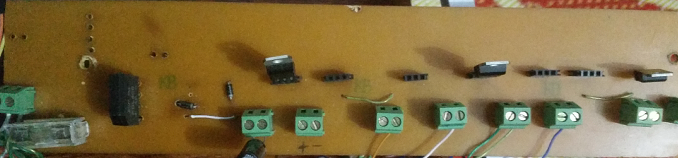

### 4.1.2- Input and output voltage and current measurement

5.1.7- PCB implementation

1. PCB implementation of Input voltage measurement

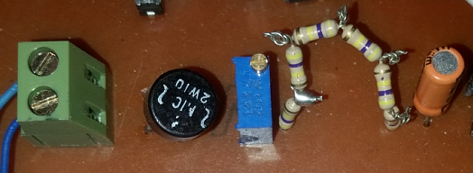

### 4.1.2- Input and output voltage and current measurement

5.1.7- PCB implementation

1. PCB implementation of output voltage measurement

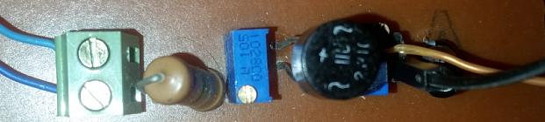

4.2.1- PIC microcontroller

5.1.7- PCB implementation

1. PCB implementation of Microcontroller

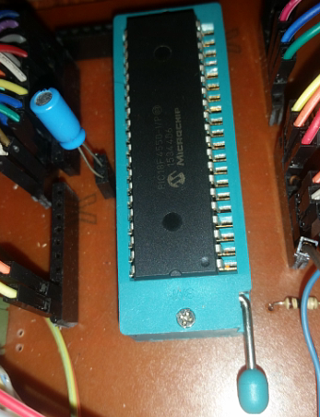

3.3- Safety and security

1. Buzzer Circuitry

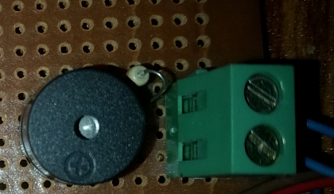

5.1.7- PCB implementation

5.1.6-Controlled SCR triggering

1. PCB implementation of SCR circuit

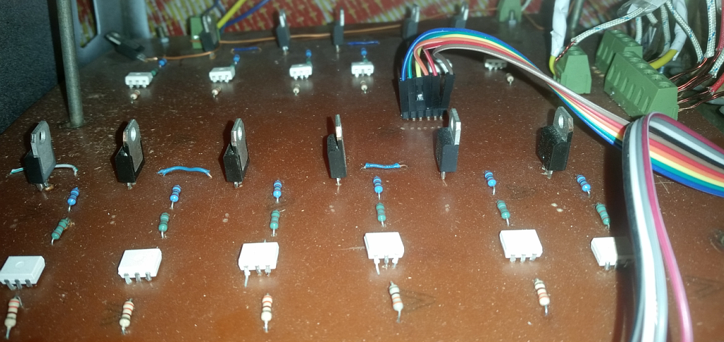

### 4.1.2- Input and output voltage and current measurement

5.1.7- PCB implementation

1. Input and output current sensors

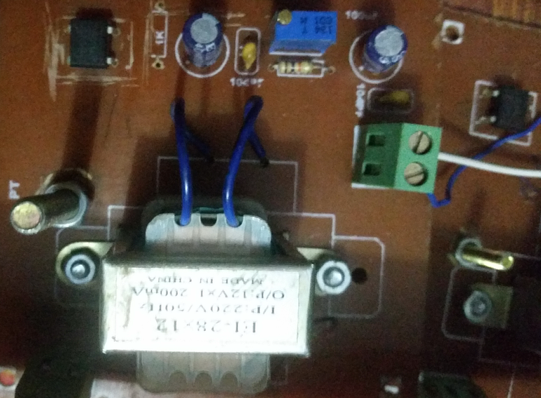

5.1.1- Transformer specifications

1. Transformer with secondary taps

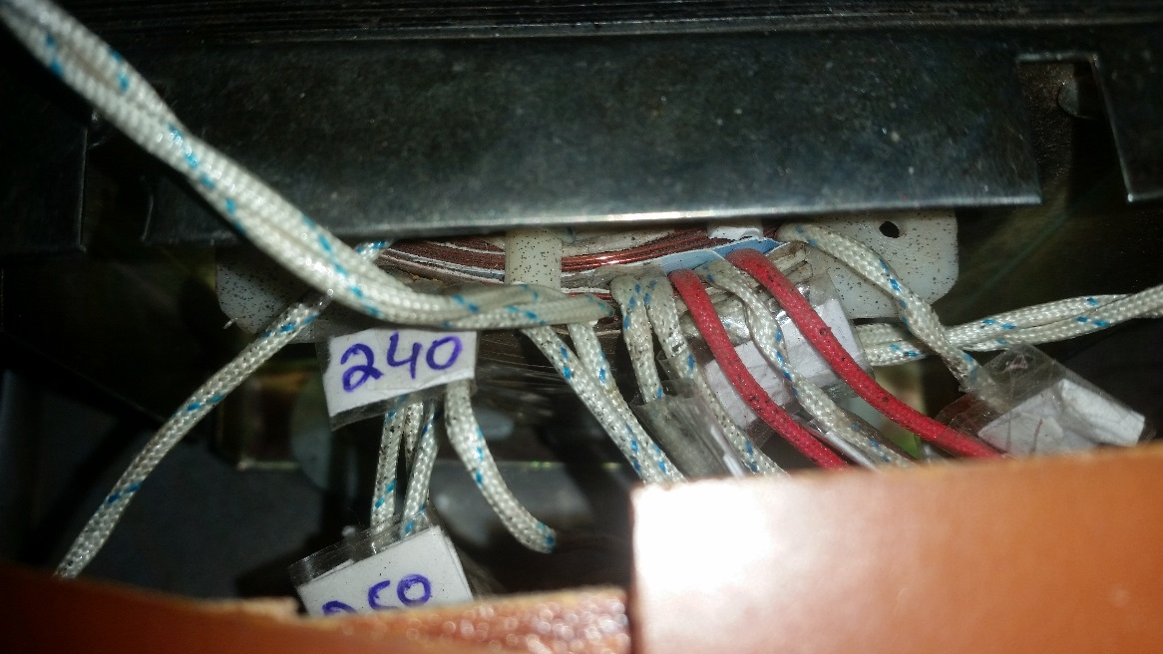

5.1.8- System Integration

1. Hardware implementation and top view of project.

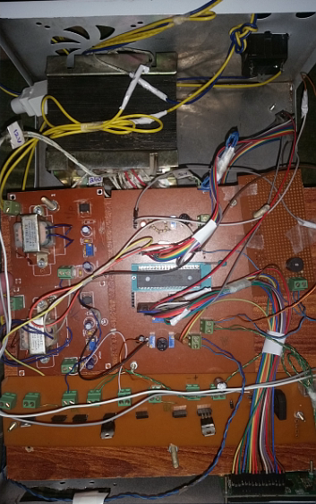

# 

# Appendix C: List of Components

* Auxiliary power supply

1. Fuse (1 ampere)
2. Full wave rectifier (KBL406)
3. Voltage regulator 7805
4. Voltage regulator 7812
5. Diodes
6. Capacitor (100uF)

* Voltage measurement

1. Full wave rectifier (2WIO)
2. Resistances (1 KΩ)
3. Variable resistance (0.96,2 MΩ)
4. Capacitor (10uF)

* Triacs Circuit

1. Resistances (330,180, 2400Ω)
2. Triacs (BTA08)
3. Optocoupler (MOC3021)

* LCD display (2*16)
* Jumper wires (male and female)
* Transformer (250 VA)
* Current sensors
* Microcontroller (PIC 18F4550)